**Application#:**

**CONVERTING NUMBERS TO WORDS**

1. **User Interface Test Screens**
   1. Verify the number 99999999999999.99 is correctly displayed in words and the name is displayed.
   2. Verify the number 0.00 is correctly displayed in words and the name is displayed.
   3. Verify the number 99.09 is correctly displayed in words and the name is displayed.
   4. Verify the number 99.19 is correctly displayed in words and the name is displayed.
   5. Verify the number 999.01 is correctly displayed in words and the name is displayed.
2. **Validations in User Interface Test Screens**
   1. Verify if the Name is a required and must be filled out.
   2. Verify if the Number is a required and must be filled out.
   3. Verify if the given Number is an invalid number.
3. **Verify the Web Service Test Screens**
   1. Verify the web service my entering and number and see if it’s returning the result in correct form of words.
4. **User Interface Test Screens**
   1. Verify the number 99999999999999.99 is correctly displayed in words and the name is displayed.

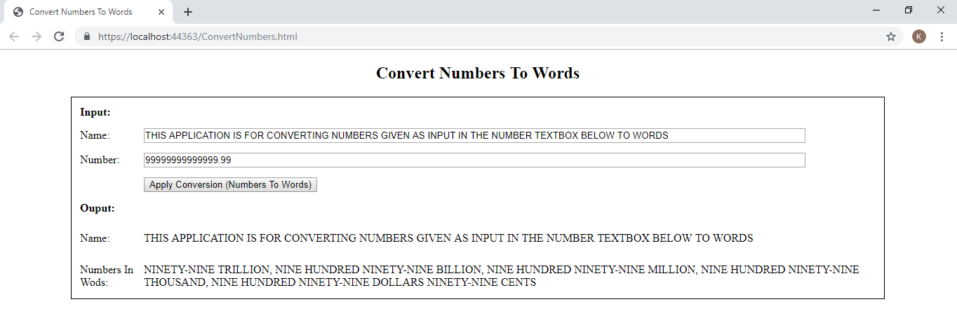

* 1. Verify the number 0.00 is correctly displayed in words and the name is displayed.

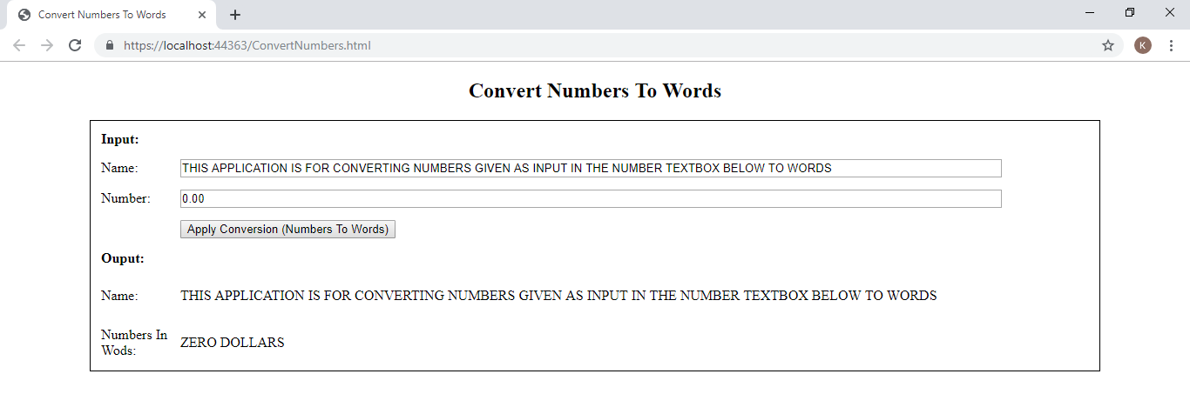

* 1. Verify the number 99.09 is correctly displayed in words and the name is displayed.

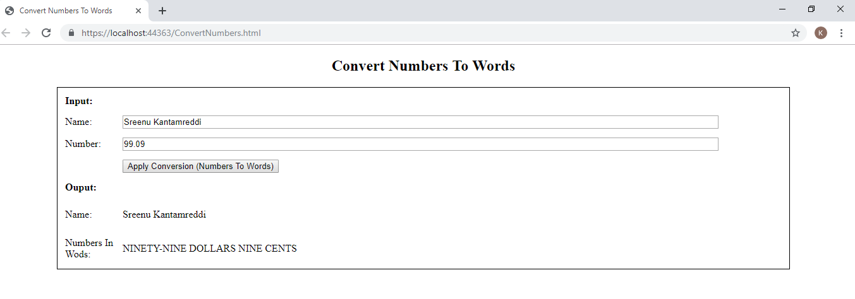

* 1. Verify the number 99.19 is correctly displayed in words and the name is displayed.

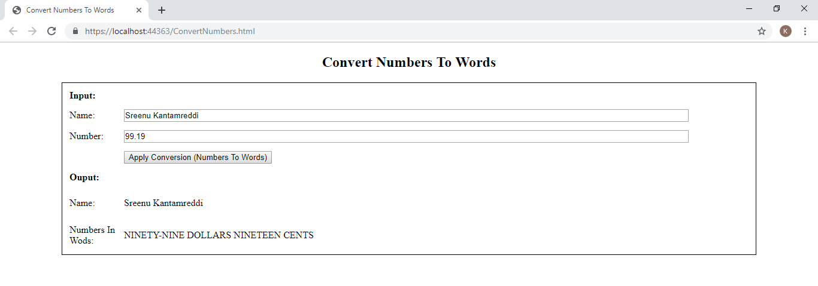

* 1. Verify the number 999.01 is correctly displayed in words and the name is displayed.

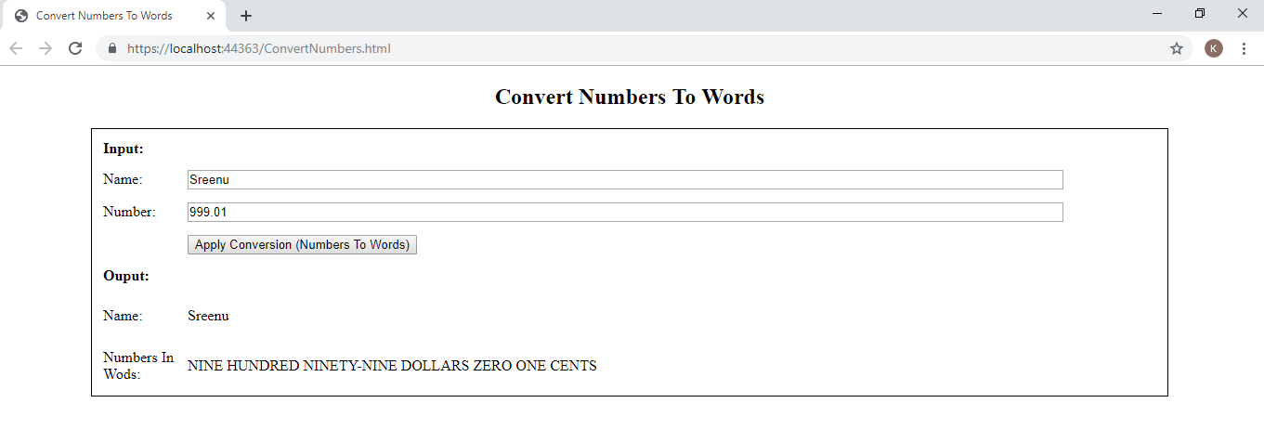

1. **Validations in User Interface Test Screens**
   1. Verify if the Name is a required and must be filled out.

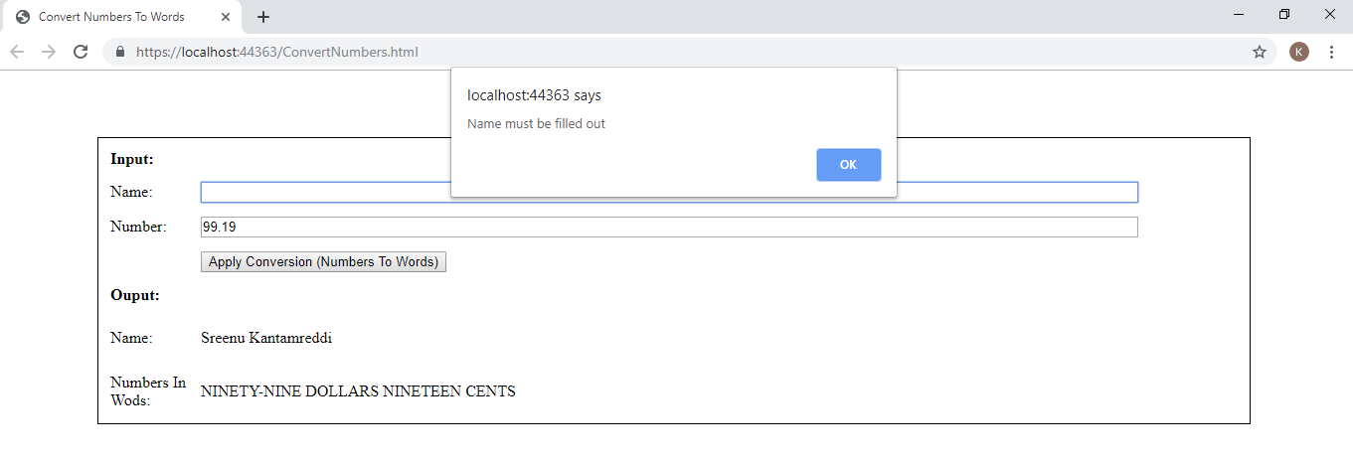

* 1. Verify if the Number is a required and must be filled out.

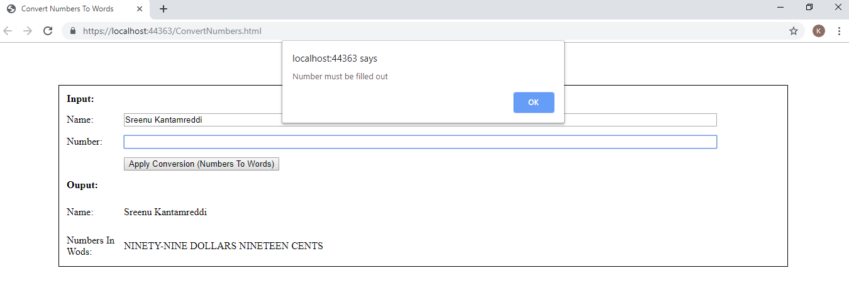

* 1. Verify if the given Number is an invalid number.

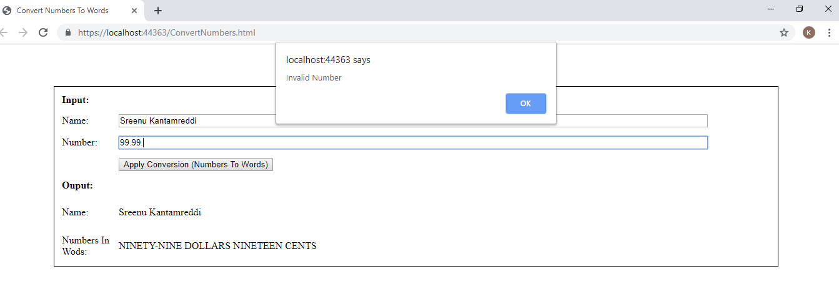

1. **Verify the Web Service Test Screens**
   1. Verify the web service my entering and number and see if it’s returning the result in correct form of words.

**Web Service Test Screens**

